ML | Introduction to Data in Machine Learning

DATA: It can be any unprocessed fact, value, text, sound, or picture that is not being interpreted and analyzed. Data is the most important part of all Data Analytics, Machine Learning, Artificial Intelligence. Without data, we can’t train any model and all modern research and automation will go in vain. Big Enterprises are spending lots of money just to gather as much certain data as possible.

Example: Why did Facebook acquire WhatsApp by paying a huge price of $19 billion?
The answer is very simple and logical – it is to have access to the users’ information that Facebook may not have but WhatsApp will have. This information of their users is of paramount importance to Facebook as it will facilitate the task of improvement in their services.
INFORMATION: Data that has been interpreted and manipulated and has now some meaningful inference for the users.
KNOWLEDGE: Combination of inferred information, experiences, learning, and insights. Results in awareness or concept building for an individual or organization.
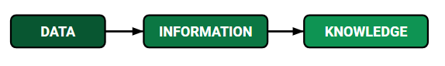
How we split data in Machine Learning?
- Training Data: The part of data we use to train our model. This is the data that your model actually sees(both input and output) and learns from.
- Validation Data: The part of data that is used to do a frequent evaluation of the model, fit on the training dataset along with improving involved hyperparameters (initially set parameters before the model begins learning). This data plays its part when the model is actually training.
- Testing Data: Once our model is completely trained, testing data provides an unbiased evaluation. When we feed in the inputs of Testing data, our model will predict some values(without seeing actual output). After prediction, we evaluate our model by comparing it with the actual output present in the testing data. This is how we evaluate and see how much our model has learned from the experiences feed in as training data, set at the time of training.
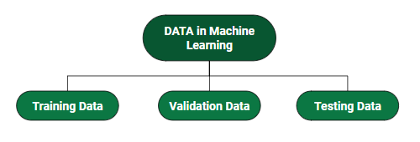
Consider an example:
There’s a Shopping Mart Owner who conducted a survey for which he has a long list of questions and answers that he had asked from the customers, this list of questions and answers is DATA. Now every time when he wants to infer anything and can’t just go through each and every question of thousands of customers to find something relevant as it would be time-consuming and not helpful. In order to reduce this overhead and time wastage and to make work easier, data is manipulated through software, calculations, graphs, etc. as per own convenience, this inference from manipulated data is Information. So, Data is a must for Information. Now Knowledge has its role in differentiating between two individuals having the same information. Knowledge is actually not technical content but is linked to the human thought process.
Different Forms of Data
- Numeric Data : If a feature represents a characteristic measured in numbers , it is called a numeric feature.
- Categorical Data : A categorical feature is an attribute that can take on one of the limited , and usually fixed number of possible values on the basis of some qualitative property . A categorical feature is also called a nominal feature.
- Ordinal Data : This denotes a nominal variable with categories falling in an ordered list . Examples include clothing sizes such as small, medium , and large , or a measurement of customer satisfaction on a scale from “not at all happy” to “very happy”.
Properties of Data –
- Volume: Scale of Data. With the growing world population and technology at exposure, huge data is being generated each and every millisecond.
- Variety: Different forms of data – healthcare, images, videos, audio clippings.
- Velocity: Rate of data streaming and generation.
- Value: Meaningfulness of data in terms of information that researchers can infer from it.
- Veracity: Certainty and correctness in data we are working on.
Some facts about Data:
- As compared to 2005, 300 times i.e. 40 Zettabytes (1ZB=10^21 bytes) of data will be generated by 2020.
- By 2011, the healthcare sector has a data of 161 Billion Gigabytes
- 400 Million tweets are sent by about 200 million active users per day
- Each month, more than 4 billion hours of video streaming is done by the users.
- 30 Billion different types of content are shared every month by the user.
- It is reported that about 27% of data is inaccurate and so 1 in 3 business idealists or leaders don’t trust the information on which they are making decisions.
The above-mentioned facts are just a glimpse of the actually existing huge data statistics. When we talk in terms of real-world scenarios, the size of data currently presents and is getting generated each and every moment is beyond our mental horizons to imagine.

ML | Understanding Data Processing
Data Processing is the task of converting data from a given form to a much more usable and desired form i.e. making it more meaningful and informative. Using Machine Learning algorithms, mathematical modeling, and statistical knowledge, this entire process can be automated. The output of this complete process can be in any desired form like graphs, videos, charts, tables, images, and many more, depending on the task we are performing and the requirements of the machine. This might seem to be simple but when it comes to massive organizations like Twitter, Facebook, Administrative bodies like Parliament, UNESCO, and health sector organizations, this entire process needs to be performed in a very structured manner. So, the steps to perform are as follows:

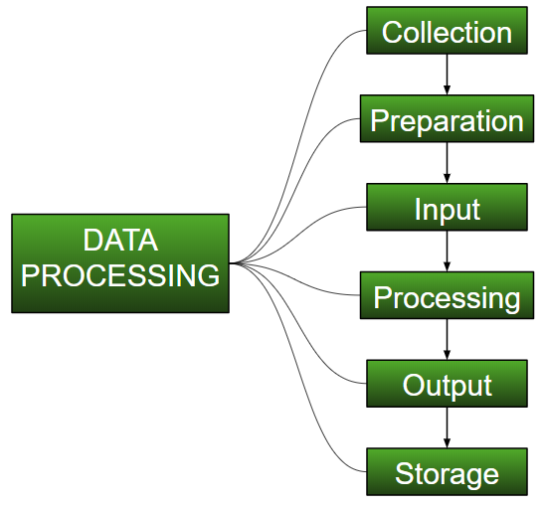

- Collection :
The most crucial step when starting with ML is to have data of good quality and accuracy. Data can be collected from any authenticated source like data.gov.in, Kaggle or UCI dataset repository. For example, while preparing for a competitive exam, students study from the best study material that they can access so that they learn the best to obtain the best results. In the same way, high-quality and accurate data will make the learning process of the model easier and better and at the time of testing, the model would yield state-of-the-art results.
A huge amount of capital, time and resources are consumed in collecting data. Organizations or researchers have to decide what kind of data they need to execute their tasks or research.
Example: Working on the Facial Expression Recognizer, needs numerous images having a variety of human expressions. Good data ensures that the results of the model are valid and can be trusted upon.
- Preparation :
The collected data can be in a raw form which can’t be directly fed to the machine. So, this is a process of collecting datasets from different sources, analyzing these datasets and then constructing a new dataset for further processing and exploration. This preparation can be performed either manually or from the automatic approach. Data can also be prepared in numeric forms also which would fasten the model’s learning.
Example: An image can be converted to a matrix of N X N dimensions, the value of each cell will indicate the image pixel.
- Input :
Now the prepared data can be in the form that may not be machine-readable, so to convert this data to the readable form, some conversion algorithms are needed. For this task to be executed, high computation and accuracy is needed. Example: Data can be collected through the sources like MNIST Digit data(images), Twitter comments, audio files, video clips.
- Processing :
This is the stage where algorithms and ML techniques are required to perform the instructions provided over a large volume of data with accuracy and optimal computation.
- Output :
In this stage, results are procured by the machine in a meaningful manner which can be inferred easily by the user. Output can be in the form of reports, graphs, videos, etc
- Storage :
This is the final step in which the obtained output and the data model data and all the useful information are saved for future use.

Python | Create Test DataSets using Sklearn

Python’s Sklearn library provides a great sample dataset generator which will help you to create your own custom dataset. It’s fast and very easy to use. Following are the types of samples it provides.
For all the above methods you need to import sklearn.datasets.samples_generator.

# importing libraries
from sklearn.datasets import make_blobs

# matplotlib for ploting
from matplotlib import pyplot as plt
from matplotlib import style

sklearn.datasets.make_blobs

# Creating Test DataSets using sklearn.datasets.make_blobs
from sklearn.datasets import make_blobs
from matplotlib import pyplot as plt
from matplotlib import style

style.use("fivethirtyeight")

X, y = make_blobs(n_samples = 100, centers = 3,
cluster_std = 1, n_features = 2)

plt.scatter(X[:, 0], X[:, 1], s = 40, color = 'g')
plt.xlabel("X")
plt.ylabel("Y")

plt.show()
plt.clf()

Output:
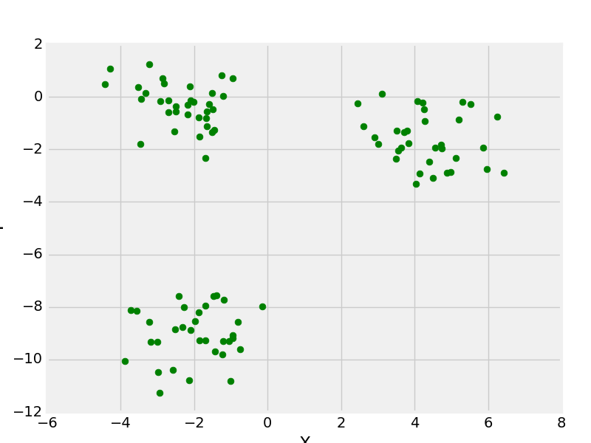
make_blobs with 3 centers

sklearn.datasets.make_moon

# Creating Test DataSets using sklearn.datasets.make_moon
from sklearn.datasets import make_moons
from matplotlib import pyplot as plt
from matplotlib import style

X, y = make_moons(n_samples = 1000, noise = 0.1)
plt.scatter(X[:, 0], X[:, 1], s = 40, color ='g')
plt.xlabel("X")
plt.ylabel("Y")

plt.show()
plt.clf()

Output:
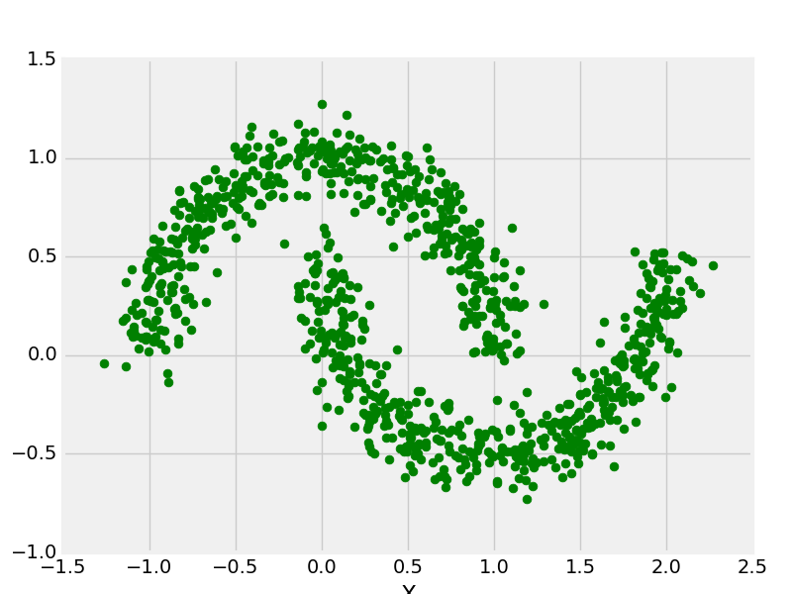
make_moons with 1000 data points

sklearn.datasets.make_circle

# Creating Test DataSets using sklearn.datasets.make_circles
from sklearn.datasets import make_circles
from matplotlib import pyplot as plt
from matplotlib import style

style.use("fivethirtyeight")

X, y = make_circles(n_samples = 100, noise = 0.02)
plt.scatter(X[:, 0], X[:, 1], s = 40, color ='g')
plt.xlabel("X")
plt.ylabel("Y")

plt.show()
plt.clf()

Output:
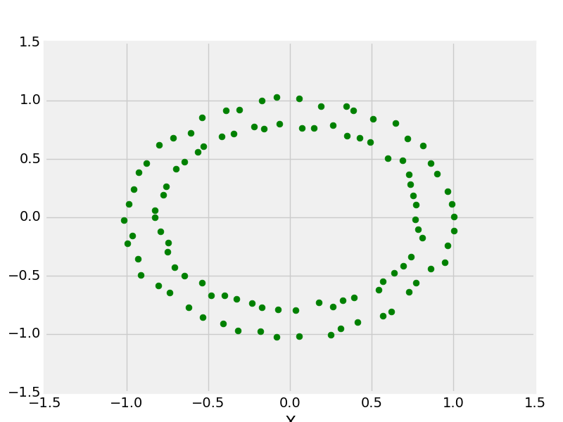
make _circle with 100 data points

Python | Generate test datasets for Machine learning
Whenever we think of Machine Learning, the first thing that comes to our mind is a dataset. While there are many datasets that you can find on websites such as Kaggle, sometimes it is useful to extract data on your own and generate your own dataset. Generating your own dataset gives you more control over the data and allows you to train your machine learning model.

In this article, we will generate random datasets using the Numpy library in Python.
Libraries needed:
-> Numpy: pip3 install numpy
-> Pandas: pip3 install pandas
-> Matplotlib: pip3 install matplotlib

Normal distribution:
In probability theory, normal or Gaussian distribution is a very common continuous probability distribution that is symmetric about the mean, showing that data near the mean are more frequent in occurrence than data far from the mean. Normal distributions used in statistics and are often used to represent real-valued random variables.
The normal distribution is the most common type of distribution in statistical analyses. The standard normal distribution has two parameters: the mean and the standard deviation. The mean is the central tendency of the distribution. The standard deviation is a measure of variability. It defines the width of the normal distribution. The standard deviation determines how far away from the mean the values tend to fall. It represents the typical distance between the observations and the average. it fits many natural phenomena, For example, heights, blood pressure, measurement error, and IQ scores follow the normal distribution.
Graph of the normal distribution:
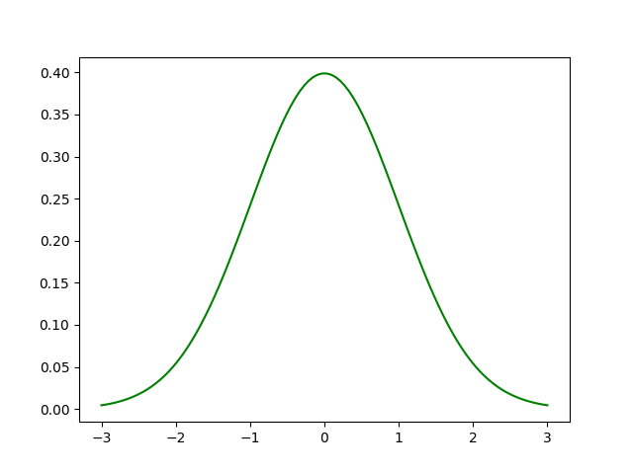
Example:

# importing libraries
import pandas as pd
import numpy as np
import matplotlib.pyplot as plt

# initialize the parameters for the normal
# distribution, namely mean and std.
# deviation

# defining the mean
mu = 0.5
# defining the standard deviation
sigma = 0.1

# The random module uses the seed value as a base
# to generate a random number. If seed value is not
# present, it takes the system’s current time.
np.random.seed(0)

# define the x co-ordinates
X = np.random.normal(mu, sigma, (395, 1))

# define the y co-ordinates
Y = np.random.normal(mu * 2, sigma * 3, (395, 1))

# plot a graph
plt.scatter(X, Y, color = 'g')
plt.show()

Output :
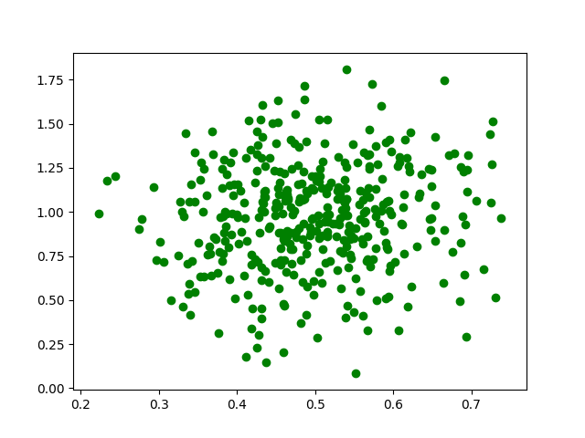
Let us look at a better example.
We will generate a dataset with 4 columns. Each column in the dataset represents a feature. The 5th column of the dataset is the output label. It varies between 0-3. This dataset can be used for training a classifier such as a logistic regression classifier, neural network classifier, Support vector machines, etc.

# importing libraries
import numpy as np
import pandas as pd
import math
import random
import matplotlib.pyplot as plt

# defining the columns using normal distribution

# column 1
point1 = abs(np.random.normal(1, 12, 100))
# column 2
point2 = abs(np.random.normal(2, 8, 100))
# column 3
point3 = abs(np.random.normal(3, 2, 100))
# column 4
point4 = abs(np.random.normal(10, 15, 100))

# x contains the features of our dataset
# the points are concatenated horizontally
# using numpy to form a feature vector.
x = np.c_[point1, point2, point3, point4]

# the output labels vary from 0-3
y = [int(np.random.randint(0, 4)) for i in range(100)]

# defining a pandas data frame to save
# the data for later use
data = pd.DataFrame()

# defining the columns of the dataset
data['col1'] = point1
data['col2'] = point2
data['col3'] = point3
data['col4'] = point4

# plotting the various features (x)
# against the labels (y).
plt.subplot(2, 2, 1)
plt.title('col1')
plt.scatter(y, point1, color ='r', label ='col1')

plt.subplot(2, 2, 2)
plt.title('Col2')
plt.scatter(y, point2, color = 'g', label ='col2')

plt.subplot(2, 2, 3)
plt.title('Col3')
plt.scatter(y, point3, color ='b', label ='col3')

plt.subplot(2, 2, 4)
plt.title('Col4')
plt.scatter(y, point4, color ='y', label ='col4')

# saving the graph
plt.savefig('data_visualization.jpg')

# displaying the graph
plt.show()

Output :
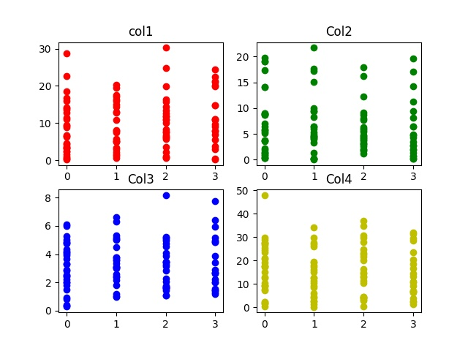

ML | Data Preprocessing in Python
Pre-processing refers to the transformations applied to our data before feeding it to the algorithm. Data Preprocessing is a technique that is used to convert the raw data into a clean data set. In other words, whenever the data is gathered from different sources it is collected in raw format which is not feasible for the analysis.

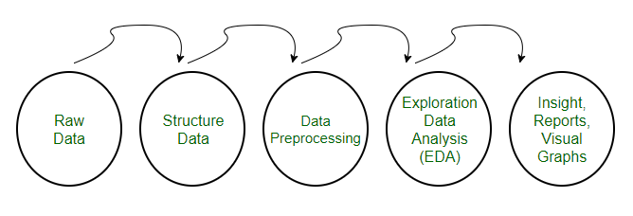
Need of Data Preprocessing
- For achieving better results from the applied model in Machine Learning projects the format of the data has to be in a proper manner. Some specified Machine Learning model needs information in a specified format, for example, Random Forest algorithm does not support null values, therefore to execute random forest algorithm null values have to be managed from the original raw data set.
- Another aspect is that the data set should be formatted in such a way that more than one Machine Learning and Deep Learning algorithm are executed in one data set, and best out of them is chosen.
This article contains 3 different data preprocessing techniques for machine learning.
The Pima Indian diabetes dataset is used in each technique.
This is a binary classification problem where all of the attributes are numeric and have different scales.
It is a great example of a dataset that can benefit from pre-processing.
You can find this dataset on the UCI Machine Learning Repository webpage.
Note that the program might not run on Geeksforgeeks IDE, but it can run easily on your local python interpreter, provided, you have installed the required libraries.
1. Rescale Data
- When our data is comprised of attributes with varying scales, many machine learning algorithms can benefit from rescaling the attributes to all have the same scale.
- This is useful for optimization algorithms used in the core of machine learning algorithms like gradient descent.
- It is also useful for algorithms that weight inputs like regression and neural networks and algorithms that use distance measures like K-Nearest Neighbors.
- We can rescale your data using scikit-learn using the MinMaxScaler class.
Code: Python code to Rescale data (between 0 and 1)

# importing libraries
import pandas
import scipy
import numpy
from sklearn.preprocessing import MinMaxScaler

# data set link
url = "https://archive.ics.uci.edu/ml/machine-learning-databases/pima-indians-diabetes/pima-indians-diabetes.data"
# data parameters
names = ['preg', 'plas', 'pres', 'skin', 'test', 'mass', 'pedi', 'age', 'class']

# preparating of dataframe using the data at given link and defined columns list
dataframe = pandas.read_csv(url, names = names)
array = dataframe.values

# separate array into input and output components
X = array[:,0:8]
Y = array[:,8]

# initialising the MinMaxScaler
scaler = MinMaxScaler(feature_range=(0, 1))
# learning the statistical parameters for each of the data and transforming
rescaledX = scaler.fit_transform(X)

# summarize transformed data
numpy.set_printoptions(precision=3)
print(rescaledX[0:5,:])

After rescaling see that all of the values are in the range between 0 and 1.
Output:
[[ 0.353 0.744 0.59 0.354 0.0 0.501 0.234 0.483]
[ 0.059 0.427 0.541 0.293 0.0 0.396 0.117 0.167]
[ 0.471 0.92 0.525 0. 0.0 0.347 0.254 0.183]
[ 0.059 0.447 0.541 0.232 0.111 0.419 0.038 0.0 ]
[ 0.0 0.688 0.328 0.354 0.199 0.642 0.944 0.2 ]]
2. Binarize Data (Make Binary)
- We can transform our data using a binary threshold. All values above the threshold are marked 1 and all equal to or below are marked as 0.
- This is called binarizing your data or threshold your data. It can be useful when you have probabilities that you want to make crisp values. It is also useful when feature engineering and you want to add new features that indicate something meaningful.
- We can create new binary attributes in Python using scikit-learn with the Binarizer class.
Code: Python code for binarization

# import libraries
from sklearn.preprocessing import Binarizer
import pandas
import numpy

# data set link
url = "https://archive.ics.uci.edu/ml/machine-learning-databases/pima-indians-diabetes/pima-indians-diabetes.data"
# data parameters
names = ['preg', 'plas', 'pres', 'skin', 'test', 'mass', 'pedi', 'age', 'class']

# preparating of dataframe using the data at given link and defined columns list
dataframe = pandas.read_csv(url, names = names)
array = dataframe.values

# separate array into input and output components
X = array[:, 0:8]
Y = array[:, 8]
binarizer = Binarizer(threshold = 0.0).fit(X)
binaryX = binarizer.transform(X)

# summarize transformed data
numpy.set_printoptions(precision = 3)
print(binaryX[0:5,:])

We can see that all values equal or less than 0 are marked 0 and all of those above 0 are marked 1.
Output:
[[ 1. 1. 1. 1. 0. 1. 1. 1.]
[ 1. 1. 1. 1. 0. 1. 1. 1.]
[ 1. 1. 1. 0. 0. 1. 1. 1.]
[ 1. 1. 1. 1. 1. 1. 1. 1.]
[ 0. 1. 1. 1. 1. 1. 1. 1.]]
3. Standardize Data
- Standardization is a useful technique to transform attributes with a Gaussian distribution and differing means and standard deviations to a standard Gaussian distribution with a mean of 0 and a standard deviation of 1.
- We can standardize data using scikit-learn with the StandardScaler class.
Code: Python code to Standardize data (0 mean, 1 stdev)

# importing libraries
from sklearn.preprocessing import StandardScaler
import pandas
import numpy

# data set link
url = "https://archive.ics.uci.edu/ml/machine-learning-databases/pima-indians-diabetes/pima-indians-diabetes.data"
# data parameters
names = ['preg', 'plas', 'pres', 'skin', 'test', 'mass', 'pedi', 'age', 'class']

# preparating of dataframe using the data at given link and defined columns list
dataframe = pandas.read_csv(url, names = names)
array = dataframe.values

# separate array into input and output components
X = array[:, 0:8]
Y = array[:, 8]
scaler = StandardScaler().fit(X)
rescaledX = scaler.transform(X)

# summarize transformed data
numpy.set_printoptions(precision = 3)
print(rescaledX[0:5,:])

The values for each attribute now have a mean value of 0 and a standard deviation of 1.
Output:
[[ 0.64 0.848 0.15 0.907 -0.693 0.204 0.468 1.426]
[-0.845 -1.123 -0.161 0.531 -0.693 -0.684 -0.365 -0.191]
[ 1.234 1.944 -0.264 -1.288 -0.693 -1.103 0.604 -0.106]
[-0.845 -0.998 -0.161 0.155 0.123 -0.494 -0.921 -1.042]
[-1.142 0.504 -1.505 0.907 0.766 1.41 5.485 -0.02 ]]

ML | Overview of Data Cleaning
Introduction:
Data cleaning is one of the important parts of machine learning. It plays a significant part in building a model. It surely isn’t the fanciest part of machine learning and at the same time, there aren’t any hidden tricks or secrets to uncover. However, the success or failure of a project relies on proper data cleaning. Professional data scientists usually invest a very large portion of their time in this step because of the belief that “Better data beats fancier algorithms”.
If we have a well-cleaned dataset, there are chances that we can get achieve good results with simple algorithms also, which can prove very beneficial at times especially in terms of computation when the dataset size is large.

Obviously, different types of data will require different types of cleaning. However, this systematic approach can always serve as a good starting point.
Steps involved in Data Cleaning:
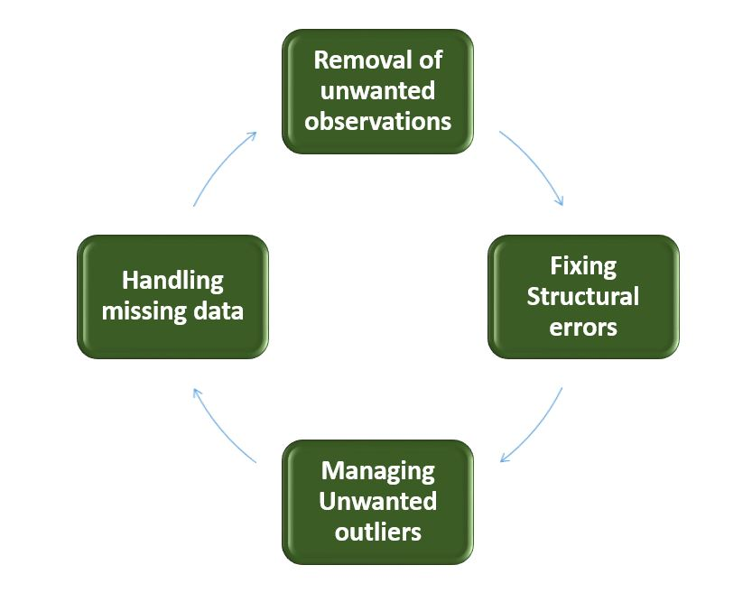

- Removal of unwanted observations
This includes deleting duplicate/ redundant or irrelevant values from your dataset. Duplicate observations most frequently arise during data collection and Irrelevant observations are those that don’t actually fit the specific problem that you’re trying to solve.
  - Redundant observations alter the efficiency by a great extent as the data repeats and may add towards the correct side or towards the incorrect side, thereby producing unfaithful results.
  - Irrelevant observations are any type of data that is of no use to us and can be removed directly.
- Fixing Structural errors
The errors that arise during measurement, transfer of data, or other similar situations are called structural errors. Structural errors include typos in the name of features, the same attribute with a different name, mislabeled classes, i.e. separate classes that should really be the same, or inconsistent capitalization.
  - For example, the model will treat America and America as different classes or values, though they represent the same value or red, yellow, and red-yellow as different classes or attributes, though one class can be included in the other two classes. So, these are some structural errors that make our model inefficient and give poor quality results.
- Managing Unwanted outliers
Outliers can cause problems with certain types of models. For example, linear regression models are less robust to outliers than decision tree models. Generally, we should not remove outliers until we have a legitimate reason to remove them. Sometimes, removing them improves performance, sometimes not. So, one must have a good reason to remove the outlier, such as suspicious measurements that are unlikely to be part of real data.
- Handling missing data
Missing data is a deceptively tricky issue in machine learning. We cannot just ignore or remove the missing observation. They must be handled carefully as they can be an indication of something important. The two most common ways to deal with missing data are:
  - Dropping observations with missing values.
    - The fact that the value was missing may be informative in itself.
    - Plus, in the real world, you often need to make predictions on new data even if some of the features are missing!
  - Imputing the missing values from past observations.
    - Again, “missingness” is almost always informative in itself, and you should tell your algorithm if a value was missing.
    - Even if you build a model to impute your values, you’re not adding any real information. You’re just reinforcing the patterns already provided by other features.
Missing data is like missing a puzzle piece. If you drop it, that’s like pretending the puzzle slot isn’t there. If you impute it, that’s like trying to squeeze in a piece from somewhere else in the puzzle.
So, missing data is always an informative and an indication of something important. And we must be aware of our algorithm of missing data by flagging it. By using this technique of flagging and filling, you are essentially allowing the algorithm to estimate the optimal constant for missingness, instead of just filling it in with the mean.
Some data cleansing tools
- Openrefine
- Trifacta Wrangler
- TIBCO Clarity
- Cloudingo
- IBM Infosphere Quality Stage
Conclusion:
So, we have discussed four different steps in data cleaning to make the data more reliable and to produce good results. After properly completing the Data Cleaning steps, we’ll have a robust dataset that avoids many of the most common pitfalls. This step should not be rushed as it proves very beneficial in the further process.

ML | Feature Scaling – Part 1
Feature Scaling is a technique to standardize the independent features present in the data in a fixed range. It is performed during the data pre-processing.

Working:
Given a data-set with features- Age, Salary, BHK Apartment with the data size of 5000 people, each having these independent data features.
Each data point is labeled as:
- Class1- YES (means with the given Age, Salary, BHK Apartment feature value one can buy the property)
- Class2- NO (means with the given Age, Salary, BHK Apartment feature value one can’t buy the property).
Using a dataset to train the model, one aims to build a model that can predict whether one can buy a property or not with given feature values.
Once the model is trained, an N-dimensional (where N is the no. of features present in the dataset) graph with data points from the given dataset, can be created. The figure given below is an ideal representation of the model.
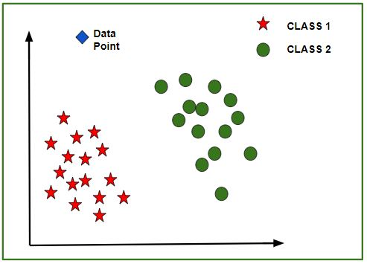
As shown in the figure, star data points belong to Class1 – Yes and circles represent Class2 – No labels, and the model gets trained using these data points. Now a new data point (diamond as shown in the figure) is given and it has different independent values for the 3 features (Age, Salary, BHK Apartment) mentioned above. The model has to predict whether this data point belongs to Yes or No.
Prediction of the class of new data points:
The model calculates the distance of this data point from the centroid of each class group. Finally, this data point will belong to that class, which will have a minimum centroid distance from it.
The distance can be calculated between centroid and data point using these methods-
- Euclidean Distance: It is the square root of the sum of squares of differences between the coordinates (feature values – Age, Salary, BHK Apartment) of data point and centroid of each class. This formula is given by the Pythagorean theorem.
where x is Data Point value, y is Centroid value and k is no. of feature values, Example: given data set has k = 3
- Manhattan Distance: It is calculated as the sum of absolute differences between the coordinates (feature values) of data point and centroid of each class.
- Minkowski Distance: It is a generalization of the above two methods. As shown in the figure, different values can be used for finding r.
Need of Feature Scaling:
The given data set contains 3 features – Age, Salary, BHK Apartment. Consider a range of 10- 60 for Age, 1 Lac- 40 Lacs for Salary, 1- 5 for BHK of Flat. All these features are independent of each other.
Suppose the centroid of class 1 is [40, 22 Lacs, 3] and the data point to be predicted is [57, 33 Lacs, 2].
Using Manhattan Method,
Distance = (|(40 - 57)| + |(2200000 - 3300000)| + |(3 - 2)|)
It can be seen that the Salary feature will dominate all other features while predicting the class of the given data point and since all the features are independent of each other i.e. a person’s salary has no relation with his/her age or what requirement of the flat he/she has. This means that the model will always predict wrong.
So, the simple solution to this problem is Feature Scaling. Feature Scaling Algorithms will scale Age, Salary, BHK in a fixed range say [-1, 1] or [0, 1]. And then no feature can dominate others.

ML | Feature Scaling – Part 2
Feature Scaling is a technique to standardize the independent features present in the data in a fixed range. It is performed during the data pre-processing to handle highly varying magnitudes or values or units. If feature scaling is not done, then a machine learning algorithm tends to weigh greater values, higher and consider smaller values as the lower values, regardless of the unit of the values.

Example: If an algorithm is not using the feature scaling method then it can consider the value 3000 meters to be greater than 5 km but that’s actually not true and in this case, the algorithm will give wrong predictions. So, we use Feature Scaling to bring all values to the same magnitudes and thus, tackle this issue.
Techniques to perform Feature Scaling
Consider the two most important ones:
- Min-Max Normalization: This technique re-scales a feature or observation value with distribution value between 0 and 1.
- Standardization: It is a very effective technique which re-scales a feature value so that it has distribution with 0 mean value and variance equals to 1.
Download the dataset:
Go to the link and download Data_for_Feature_Scaling.csv
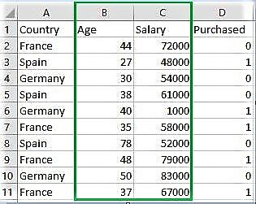
Code: Python code explaining the working of Feature Scaling on the data
# Python code explaining How to
# perform Feature Scaling

""" PART 1
Importing Libraries """

import numpy as np
import matplotlib.pyplot as plt
import pandas as pd

# Sklearn library
from sklearn import preprocessing

""" PART 2
Importing Data """

data_set = pd.read_csv('C:\\Users\\dell\\Desktop\\Data_for_Feature_Scaling.csv')
data_set.head()

# here Features - Age and Salary columns
# are taken using slicing
# to handle values with varying magnitude
x = data_set.iloc[:, 1:3].values
print ("\nOriginal data values : \n", x)

""" PART 4
Handling the missing values """

from sklearn import preprocessing

""" MIN MAX SCALER """

min_max_scaler = preprocessing.MinMaxScaler(feature_range =(0, 1))

# Scaled feature
x_after_min_max_scaler = min_max_scaler.fit_transform(x)

print ("\nAfter min max Scaling : \n", x_after_min_max_scaler)

""" Standardisation """

Standardisation = preprocessing.StandardScaler()

# Scaled feature
x_after_Standardisation = Standardisation.fit_transform(x)

print ("\nAfter Standardisation : \n", x_after_Standardisation)

Output :
Country Age Salary Purchased
0 France 44 72000 0
1 Spain 27 48000 1
2 Germany 30 54000 0
3 Spain 38 61000 0
4 Germany 40 1000 1

Original data values :
[[ 44 72000]
[ 27 48000]
[ 30 54000]
[ 38 61000]
[ 40 1000]
[ 35 58000]
[ 78 52000]
[ 48 79000]
[ 50 83000]
[ 37 67000]]

After min max Scaling :
[[ 0.33333333 0.86585366]
[ 0. 0.57317073]
[ 0.05882353 0.64634146]
[ 0.21568627 0.73170732]
[ 0.25490196 0. ]
[ 0.15686275 0.69512195]
[ 1. 0.62195122]
[ 0.41176471 0.95121951]
[ 0.45098039 1. ]
[ 0.19607843 0.80487805]]

After Standardisation :
[[ 0.09536935 0.66527061]
[-1.15176827 -0.43586695]
[-0.93168516 -0.16058256]
[-0.34479687 0.16058256]
[-0.1980748 -2.59226136]
[-0.56487998 0.02294037]
[ 2.58964459 -0.25234403]
[ 0.38881349 0.98643574]
[ 0.53553557 1.16995867]
[-0.41815791 0.43586695]]

ML | Label Encoding of datasets in Python
In machine learning, we usually deal with datasets that contain multiple labels in one or more than one columns. These labels can be in the form of words or numbers. To make the data understandable or in human-readable form, the training data is often labelled in words.


Label Encoding refers to converting the labels into a numeric form so as to convert them into the machine-readable form. Machine learning algorithms can then decide in a better way how those labels must be operated. It is an important pre-processing step for the structured dataset in supervised learning.
Example :
Suppose we have a column Height in some dataset.
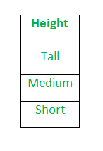
After applying label encoding, the Height column is converted into:
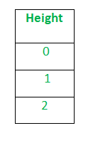
where 0 is the label for tall, 1 is the label for medium, and 2 is a label for short height.
We apply Label Encoding on iris dataset on the target column which is Species. It contains three species Iris-setosa, Iris-versicolor, Iris-virginica.

# Import libraries
import numpy as np
import pandas as pd

# Import dataset
df = pd.read_csv('../../data/Iris.csv')

df['species'].unique()

Output:
array(['Iris-setosa', 'Iris-versicolor', 'Iris-virginica'], dtype=object)
After applying Label Encoding –

# Import label encoder
from sklearn import preprocessing

# label_encoder object knows how to understand word labels.
label_encoder = preprocessing.LabelEncoder()

# Encode labels in column 'species'.
df['species']= label_encoder.fit_transform(df['species'])

df['species'].unique()

Output:
array([0, 1, 2], dtype=int64)
Limitation of label Encoding
Label encoding converts the data in machine-readable form, but it assigns a unique number(starting from 0) to each class of data. This may lead to the generation of priority issues in the training of data sets. A label with a high value may be considered to have high priority than a label having a lower value.
Example
An attribute having output classes Mexico, Paris, Dubai. On Label Encoding, this column lets Mexico is replaced with 0, Paris is replaced with 1, and Dubai is replaced with 2.
With this, it can be interpreted that Dubai has high priority than Mexico and Paris while training the model, But actually, there is no such priority relation between these cities here.

ML | One Hot Encoding to treat Categorical data parameters
Most Machine Learning algorithms cannot work with categorical data and needs to be converted into numerical data. Sometimes in datasets, we encounter columns that contain categorical features (string values) for example parameter Gender will have categorical parameters like Male, Female. These labels have no specific order of preference and also since the data is string labels, machine learning models misinterpreted that there is some sort of hierarchy in them.

One approach to solve this problem can be label encoding where we will assign a numerical value to these labels for example Male and Female mapped to 0 and 1. But this can add bias in our model as it will start giving higher preference to the Female parameter as 1>0 and ideally both labels are equally important in the dataset. To deal with this issue we will use One Hot Encoding technique.

One Hot Encoding:
In this technique, the categorical parameters will prepare separate columns for both Male and Female labels. So, wherever there is Male, the value will be 1 in Male column and 0 in Female column, and vice-versa. Let’s understand with an example: Consider the data where fruits and their corresponding categorical values and prices are given.
Fruit | Categorical value of fruit | Price
apple | 1 | 5
mango | 2 | 10
apple | 1 | 15
orange | 3 | 20
The output after one-hot encoding of the data is given as follows,
apple | mango | orange | price
1 | 0 | 0 | 5
0 | 1 | 0 | 10
1 | 0 | 0 | 15
0 | 0 | 1 | 20
Code: Python code implementation of Manual One-Hot Encoding Technique Loading the data

# Program for demonstration of one hot encoding

# import libraries
import numpy as np
import pandas as pd

# import the data required
data = pd.read_csv("employee_data.csv")
print(data.head())

Output: 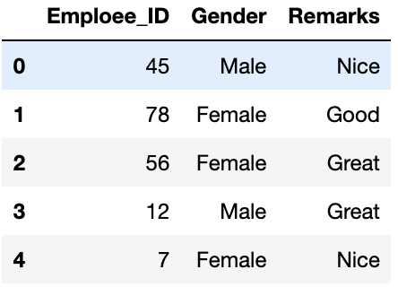
Checking for the labels in the categorical parameters

print(data['Gender'].unique())
print(data['Remarks'].unique())

Output:
array(['Male', 'Female'], dtype=object)
array(['Nice', 'Good', 'Great'], dtype=object)
Checking for the label counts in the categorical parameters

data['Gender'].value_counts()
data['Remarks'].value_counts()

Output:
Female 7
Male 5
Name: Gender, dtype: int64

Nice 5
Great 4
Good 3
Name: Remarks, dtype: int64
One-Hot encoding the categorical parameters using get_dummies()

one_hot_encoded_data = pd.get_dummies(data, columns = ['Remarks', 'Gender'])
print(one_hot_encoded_data)

Output: 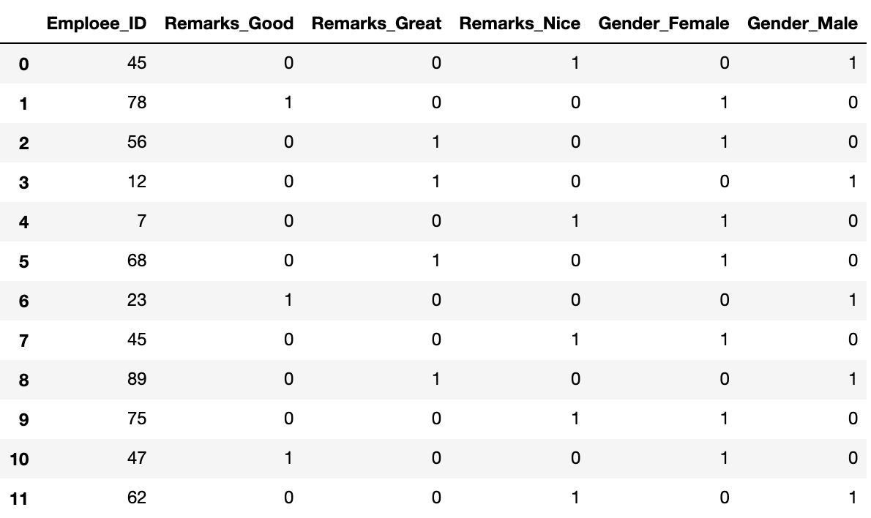
We can observe that we have 3 Remarks and 2 Gender columns in the data. However, you can just use n-1 columns to define parameters if it has n unique labels. For example if we only keep Gender_Female column and drop Gender_Male column, then also we can convey the entire information as when label is 1, it means female and when label is 0 it means male. This way we can encode the categorical data and reduce the number of parameters as well.
One Hot Encoding using Sci-kit learn Library:
One hot encoding algorithm is an encoding system of Sci-kit learn library. One Hot Encoding is used to convert numerical categorical variables into binary vectors. Before implementing this algorithm. Make sure the categorical values must be label encoded as one hot encoding takes only numerical categorical values.

#importing libraries
import pandas as pd
import numpy as np
from sklearn.preprocessing import OneHotEncoder

#Retrieving data
data = pd.read_csv('Employee_data.csv')

# Converting type of columns to category
data['Gender']=data['Gender'].astype('category')
data['Remarks']=data['Remarks'].astype('category')

#Assigning numerical values and storing it in another columns
data['Gen_new']=data['Gender'].cat.codes
data['Rem_new']=data['Remarks'].cat.codes

#Create an instance of One-hot-encoder
enc=OneHotEncoder()

#Passing encoded columns
'''
NOTE: we have converted the enc.fit_transform() method to array because the fit_transform method
of OneHotEncoder returns SpiPy sparse matrix this enables us to save space when we
have huge number of categorical variables
'''
enc_data=pd.DataFrame(enc.fit_transform(data[['Gen_new','Rem_new']]).toarray())

#Merge with main
New_df=data.join(enc_data)

print(New_df)

Output:
Employee_Id Gender Remarks Gen_new Rem_new 0 1 2 3 4
0 45 Male Nice 1 2 0.0 1.0 0.0 0.0 1.0
1 78 Female Good 0 0 1.0 0.0 1.0 0.0 0.0
2 56 Female Great 0 1 1.0 0.0 0.0 1.0 0.0
3 12 Male Great 1 1 0.0 1.0 0.0 1.0 0.0
4 7 Female Nice 0 2 1.0 0.0 0.0 0.0 1.0
5 68 Female Great 0 1 1.0 0.0 0.0 1.0 0.0
6 23 Male Good 1 0 0.0 1.0 1.0 0.0 0.0
7 45 Female Nice 0 2 1.0 0.0 0.0 0.0 1.0
8 89 Male Great 1 1 0.0 1.0 0.0 1.0 0.0
9 75 Female Nice 0 2 1.0 0.0 0.0 0.0 1.0
10 47 Female Good 0 0 1.0 0.0 1.0 0.0 0.0
11 62 Male Nice 1 2 0.0 1.0 0.0 0.0 1.0
Using get_dummies approach:

one_hot_encoded_data = pd.get_dummies(data, columns = ['Gender','Remarks'])
print(one_hot_encoded_data)

Employee_Id Gen_new Rem_new Gender_Female Gender_Male Remarks_Good Remarks_Great Remarks_Nice
0 45 1 2 0 1 0 0 1
1 78 0 0 1 0 1 0 0
2 56 0 1 1 0 0 1 0
3 12 1 1 0 1 0 1 0
4 7 0 2 1 0 0 0 1
5 68 0 1 1 0 0 1 0
6 23 1 0 0 1 1 0 0
7 45 0 2 1 0 0 0 1
8 89 1 1 0 1 0 1 0
9 75 0 2 1 0 0 0 1
10 47 0 0 1 0 1 0 0
11 62 1 2 0 1 0 0 1

ML | Handling Imbalanced Data with SMOTE and Near Miss Algorithm in Python
In Machine Learning and Data Science we often come across a term called Imbalanced Data Distribution, generally happens when observations in one of the class are much higher or lower than the other classes. As Machine Learning algorithms tend to increase accuracy by reducing the error, they do not consider the class distribution. This problem is prevalent in examples such as Fraud Detection, Anomaly Detection, Facial recognition etc.

Standard ML techniques such as Decision Tree and Logistic Regression have a bias towards the majority class, and they tend to ignore the minority class. They tend only to predict the majority class, hence, having major misclassification of the minority class in comparison with the majority class. In more technical words, if we have imbalanced data distribution in our dataset then our model becomes more prone to the case when minority class has negligible or very lesser recall.
Imbalanced Data Handling Techniques: There are mainly 2 mainly algorithms that are widely used for handling imbalanced class distribution.
- SMOTE
- Near Miss Algorithm

SMOTE (Synthetic Minority Oversampling Technique) – Oversampling
SMOTE (synthetic minority oversampling technique) is one of the most commonly used oversampling methods to solve the imbalance problem.
It aims to balance class distribution by randomly increasing minority class examples by replicating them.
SMOTE synthesises new minority instances between existing minority instances. It generates the virtual training records by linear interpolation for the minority class. These synthetic training records are generated by randomly selecting one or more of the k-nearest neighbors for each example in the minority class. After the oversampling process, the data is reconstructed and several classification models can be applied for the processed data.
More Deep Insights of how SMOTE Algorithm work !
- Step 1: Setting the minority class set A, for each , the k-nearest neighbors of x are obtained by calculating the Euclidean distance between x and every other sample in set A.
- Step 2: The sampling rate N is set according to the imbalanced proportion. For each , N examples (i.e x1, x2, …xn) are randomly selected from its k-nearest neighbors, and they construct the set .
- Step 3: For each example (k=1, 2, 3…N), the following formula is used to generate a new example:
in which rand(0, 1) represents the random number between 0 and 1.

NearMiss Algorithm – Undersampling
NearMiss is an under-sampling technique. It aims to balance class distribution by randomly eliminating majority class examples. When instances of two different classes are very close to each other, we remove the instances of the majority class to increase the spaces between the two classes. This helps in the classification process.
To prevent problem of information loss in most under-sampling techniques, near-neighbor methods are widely used.
The basic intuition about the working of near-neighbor methods is as follows:
- Step 1: The method first finds the distances between all instances of the majority class and the instances of the minority class. Here, majority class is to be under-sampled.
- Step 2: Then, n instances of the majority class that have the smallest distances to those in the minority class are selected.
- Step 3: If there are k instances in the minority class, the nearest method will result in k*n instances of the majority class.
For finding n closest instances in the majority class, there are several variations of applying NearMiss Algorithm :
- NearMiss – Version 1 : It selects samples of the majority class for which average distances to the k closest instances of the minority class is smallest.
- NearMiss – Version 2 : It selects samples of the majority class for which average distances to the k farthest instances of the minority class is smallest.
- NearMiss – Version 3 : It works in 2 steps. Firstly, for each minority class instance, their M nearest-neighbors will be stored. Then finally, the majority class instances are selected for which the average distance to the N nearest-neighbors is the largest.
This article helps in better understanding and hands-on practice on how to choose best between different imbalanced data handling techniques.

Load libraries and data file
The dataset consists of transactions made by credit cards. This dataset has 492 fraud transactions out of 284, 807 transactions. That makes it highly unbalanced, the positive class (frauds) account for 0.172% of all transactions.
The dataset can be downloaded from here.
# import necessary modules
import pandas as pd
import matplotlib.pyplot as plt
import numpy as np
from sklearn.linear_model import LogisticRegression
from sklearn.preprocessing import StandardScaler
from sklearn.metrics import confusion_matrix, classification_report

# load the data set
data = pd.read_csv('creditcard.csv')

# print info about columns in the dataframe
print(data.info())

Output:
RangeIndex: 284807 entries, 0 to 284806
Data columns (total 31 columns):
Time 284807 non-null float64
V1 284807 non-null float64
V2 284807 non-null float64
V3 284807 non-null float64
V4 284807 non-null float64
V5 284807 non-null float64
V6 284807 non-null float64
V7 284807 non-null float64
V8 284807 non-null float64
V9 284807 non-null float64
V10 284807 non-null float64
V11 284807 non-null float64
V12 284807 non-null float64
V13 284807 non-null float64
V14 284807 non-null float64
V15 284807 non-null float64
V16 284807 non-null float64
V17 284807 non-null float64
V18 284807 non-null float64
V19 284807 non-null float64
V20 284807 non-null float64
V21 284807 non-null float64
V22 284807 non-null float64
V23 284807 non-null float64
V24 284807 non-null float64
V25 284807 non-null float64
V26 284807 non-null float64
V27 284807 non-null float64
V28 284807 non-null float64
Amount 284807 non-null float64
Class 284807 non-null int64
# normalise the amount column
data['normAmount'] = StandardScaler().fit_transform(np.array(data['Amount']).reshape(-1, 1))

# drop Time and Amount columns as they are not relevant for prediction purpose
data = data.drop(['Time', 'Amount'], axis = 1)

# as you can see there are 492 fraud transactions.
data['Class'].value_counts()

Output:
0 284315
1 492

Split the data into test and train sets
from sklearn.model_selection import train_test_split

# split into 70:30 ration
X_train, X_test, y_train, y_test = train_test_split(X, y, test_size = 0.3, random_state = 0)

# describes info about train and test set
print("Number transactions X_train dataset: ", X_train.shape)
print("Number transactions y_train dataset: ", y_train.shape)
print("Number transactions X_test dataset: ", X_test.shape)
print("Number transactions y_test dataset: ", y_test.shape)

Output:
Number transactions X_train dataset: (199364, 29)
Number transactions y_train dataset: (199364, 1)
Number transactions X_test dataset: (85443, 29)
Number transactions y_test dataset: (85443, 1)

Now train the model without handling the imbalanced class distribution
# logistic regression object
lr = LogisticRegression()

# train the model on train set
lr.fit(X_train, y_train.ravel())

predictions = lr.predict(X_test)

# print classification report
print(classification_report(y_test, predictions))

Output:
precision recall f1-score support

0 1.00 1.00 1.00 85296
1 0.88 0.62 0.73 147

accuracy 1.00 85443
macro avg 0.94 0.81 0.86 85443
weighted avg 1.00 1.00 1.00 85443
The accuracy comes out to be 100% but did you notice something strange ?
The recall of the minority class in very less. It proves that the model is more biased towards majority class. So, it proves that this is not the best model.
Now, we will apply different imbalanced data handling techniques and see their accuracy and recall results.

Using SMOTE Algorithm
You can check all the parameters from here.
print("Before OverSampling, counts of label '1': {}".format(sum(y_train == 1)))
print("Before OverSampling, counts of label '0': {} \n".format(sum(y_train == 0)))

# import SMOTE module from imblearn library
# pip install imblearn (if you don't have imblearn in your system)
from imblearn.over_sampling import SMOTE
sm = SMOTE(random_state = 2)
X_train_res, y_train_res = sm.fit_sample(X_train, y_train.ravel())

print('After OverSampling, the shape of train_X: {}'.format(X_train_res.shape))
print('After OverSampling, the shape of train_y: {} \n'.format(y_train_res.shape))

print("After OverSampling, counts of label '1': {}".format(sum(y_train_res == 1)))
print("After OverSampling, counts of label '0': {}".format(sum(y_train_res == 0)))

Output:
Before OverSampling, counts of label '1': [345]
Before OverSampling, counts of label '0': [199019]

After OverSampling, the shape of train_X: (398038, 29)
After OverSampling, the shape of train_y: (398038, )

After OverSampling, counts of label '1': 199019
After OverSampling, counts of label '0': 199019
Look! that SMOTE Algorithm has oversampled the minority instances and made it equal to majority class. Both categories have equal amount of records. More specifically, the minority class has been increased to the total number of majority class.
Now see the accuracy and recall results after applying SMOTE algorithm (Oversampling).

Prediction and Recall
lr1 = LogisticRegression()
lr1.fit(X_train_res, y_train_res.ravel())
predictions = lr1.predict(X_test)

# print classification report
print(classification_report(y_test, predictions))

Output:
precision recall f1-score support

0 1.00 0.98 0.99 85296
1 0.06 0.92 0.11 147

accuracy 0.98 85443
macro avg 0.53 0.95 0.55 85443
weighted avg 1.00 0.98 0.99 85443
Wow, We have reduced the accuracy to 98% as compared to previous model but the recall value of minority class has also improved to 92 %. This is a good model compared to the previous one. Recall is great.
Now, we will apply NearMiss technique to Under-sample the majority class and see its accuracy and recall results.

NearMiss Algorithm:
You can check all the parameters from here.
print("Before Undersampling, counts of label '1': {}".format(sum(y_train == 1)))
print("Before Undersampling, counts of label '0': {} \n".format(sum(y_train == 0)))

# apply near miss
from imblearn.under_sampling import NearMiss
nr = NearMiss()

X_train_miss, y_train_miss = nr.fit_sample(X_train, y_train.ravel())

print('After Undersampling, the shape of train_X: {}'.format(X_train_miss.shape))
print('After Undersampling, the shape of train_y: {} \n'.format(y_train_miss.shape))

print("After Undersampling, counts of label '1': {}".format(sum(y_train_miss == 1)))
print("After Undersampling, counts of label '0': {}".format(sum(y_train_miss == 0)))

Output:
Before Undersampling, counts of label '1': [345]
Before Undersampling, counts of label '0': [199019]

After Undersampling, the shape of train_X: (690, 29)
After Undersampling, the shape of train_y: (690, )

After Undersampling, counts of label '1': 345
After Undersampling, counts of label '0': 345
The NearMiss Algorithm has undersampled the majority instances and made it equal to majority class. Here, the majority class has been reduced to the total number of minority class, so that both classes will have equal number of records.

Prediction and Recall
# train the model on train set
lr2 = LogisticRegression()
lr2.fit(X_train_miss, y_train_miss.ravel())
predictions = lr2.predict(X_test)

# print classification report
print(classification_report(y_test, predictions))

Output:
precision recall f1-score support

0 1.00 0.56 0.72 85296
1 0.00 0.95 0.01 147

accuracy 0.56 85443
macro avg 0.50 0.75 0.36 85443
weighted avg 1.00 0.56 0.72 85443
This model is better than the first model because it classifies better and also the recall value of minority class is 95 %. But due to undersampling of majority class, its recall has decreased to 56 %. So in this case, SMOTE is giving me a great accuracy and recall, I’ll go ahead and use that model! 

ML | Dummy variable trap in Regression Models
Before learning about the dummy variable trap, let’s first understand what actually dummy variable is.

Dummy Variable in Regression Models:
In statistics, especially in regression models, we deal with various kinds of data. The data may be quantitative (numerical) or qualitative (categorical). The numerical data can be easily handled in regression models but we can’t use categorical data directly, it needs to be transformed in some way.
For transforming categorical attributes to numerical attributes, we can use the label encoding procedure (label encoding assigns a unique integer to each category of data). But this procedure is not alone that suitable, hence, One hot encoding is used in regression models following label encoding. This enables us to create new attributes according to the number of classes present in the categorical attribute i.e if there are n number of categories in categorical attribute, n new attributes will be created. These attributes created are called Dummy Variables. Hence, dummy variables are “proxy” variables for categorical data in regression models.
These dummy variables will be created with one-hot encoding and each attribute will have a value of either 0 or 1, representing the presence or absence of that attribute.
Dummy Variable Trap:
The Dummy variable trap is a scenario where there are attributes that are highly correlated (Multicollinear) and one variable predicts the value of others. When we use one-hot encoding for handling the categorical data, then one dummy variable (attribute) can be predicted with the help of other dummy variables. Hence, one dummy variable is highly correlated with other dummy variables. Using all dummy variables for regression models leads to a dummy variable trap. So, the regression models should be designed to exclude one dummy variable.
For Example –
Let’s consider the case of gender having two values male (0 or 1) and female (1 or 0). Including both the dummy variable can cause redundancy because if a person is not male in such case that person is a female, hence, we don’t need to use both the variables in regression models. This will protect us from the dummy variable trap.

